HOTEL INFORMATION

Recommended hotel:

NH Hotel Utrecht **** - Jaarbeursplein 24 - 3521 AR UTRECHT
Tel. : +31 (0)30 2977988 Fax: +31 (0)30 2977999
E-mail: nhutrecht@nh-hotels.com
Website http://www.nh-hotels.com

(average) Special rate per person per night and incl. breakfast € 116,84

A group reservation has been been made valid from 23 – 31 October 2013, book before Wednesday 20 September 2013.

For reservations and more information please use conference link:
http://www.nh-hotels.com/events/en/event-detail/18962/sahyog.html

Should you have questions regarding your reservation please refer to:
Group reservation’s number: 15.516.082

Alternative hotels:

- Park Plaza **** - Westplein 50 - 3531 BL UTRECHT
Reservations tel: + 31(0)800-487-6215
Tel.: + 31(0)30 2925200

Website: http://www.parkplaza.nl/utrecht-hotel-nl-3531-bl/netutrec?hotelCode=netutrec

- IBIS Hotel *** - Bizetlaan 1 - 3533 KC UTRECHT
Tel: +31(0)30 2039000
E-mail: H0880-DM@accor.com
Website http://www.ibis.com/gb/hotel-0880-ibis-utrecht/index.shtml

TRAVEL INFORMATION

From Schiphol international airport to Utrecht Central Station

* Walk to the central hall in which you’ll find the train information (NS = Nederlandse Spoorwegen = Dutch Rail) 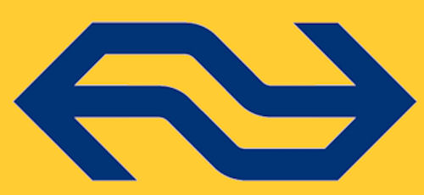

There is a direct train connection to “Utrecht Central Station” during the day every 15 minutes, during nights hours varying from every 30 to 60 minutes.
Price ticket single journey: € 8,10 second class, € 13,80 first class
Duration: 31 minutes

Should you wish to take a taxi please see http://www.utc.nl/english/airport.html for telephones, fares etc. UTC (Utrechtse Taxi Centrale) is a reliable taxi company that we can recommend to you.

From Utrecht Central Station to hotels

At the station follow the signs “Jaarbeursplein”, after some 5 minutes’ walk you go down the stairs and when arriving outside turn to the right, NH hotel is right in front of you. Park Plaza is situated next to NH hotel

After NH hotel turn left “Graadt van Roggenweg” , “Weg van de Verenigde Naties”, right “Bizetlaan” where IBIS hotel is situated. In total a 25 minutes’ walk, it is recommended to take a taxi, single fare varying from € 8,50 to € 12.50.

Any questions before, during or after your travel?
please call or mail Inge Kraft
NL Agency: + 31 (0)30 6022299
Mobile: + 31(0)6 22998087
Mail: inge.kraft@agentschapnl.nl

